The Impacts of SLR on The Kingdom of Bahrain Coastal Area

Sea Level Rise (SLR) and extreme water levels are among the most important signs of the impacts of climate change, causing major threats to human beings around the world particularly in low lying coastal areas. The potential impacts increase when populations and their related economic activities are highly concentrated along the coastal zones (McGranahan et al.,2007; Nicholls et al., 2008).

The Kingdom of Bahrain (fig. 1) as a Small Island Developing State (SIDS) has a very limited capacity to adapt to climate change - induced SLR due to the inability to accommodate significant landward migration of coastal habitats (1NCR, 2005; 2NCR-Bahrain, 2012; UNISDR, 2009a). The country has small land mass, which not exceed 750 Sq Kilometer, high population densities (1755/km²) and fast population growth rates (CITO, 2014). Most of the coastal areas of the islands do not exceed 5m above the current mean sea level (2NCR-Bahrain, 2012, Aljenaid, 2012) and most of the intensive development is located on the narrow coastal plains. It is therefore physically and economically difficult to accommodate retreating landward-migrating coastal habitats, or to establish zoning setbacks from coastal areas for new development. Coastal and marine areas are important natural resources subject to pollution, over-exploitation (2NCR-Bahrain, 2012) coastal development and extensive dredging and land reclamation (150 km2/year) (CITO, 2014).

The IPCC 4AR (Solomon, 2007) indicated that the global mean sea level was rising during the 20th Century at an average rate of 1.7 ± 0.5 mm/·yr. The rate of sea level rise has been accelerating in recent decades. Global climate models have predicted a global SLR of between 0.18m and 0.59 m. Recent studies suggest that SLR may range from 0.18 m to 0.79 m by 2090-2099 relative to 1980-1999, including an allowance of 0.2 m for uncertainties associated with the ice sheet flow.

Bahrain Islands could be affected by SLR under all scenarios. It is expected that 10% (74 km2) of coastal areas could be inundated by sea water if SLR between 0.3 -0.50 m (fig. 2), in a scenario of slow melting ice to 2050. While It could reach more than 19% of the area, which is equivalent to 145 km2, in a scenario of rapid melting ice for the same period (fig 3). As for 2100, it is expected the inundated areas will increase under all expected scenarios. It will be equivalent to 19% (145 km2) in case of non-accelerated melting of the ice, doubled to 253 km2 (33%) at a rate of melting of slow ice increasing to 51% (383 km2) at the accelerated melting of ice.

To protect the building facilities and new development along the coastline from sea level rise, Bahrain adopted a regulation for sea fill (reclamation) levels varying from 1.75 to 4.75 m, depending the shallow water bathymetry (Fig 4).

Bahrain is also one of the first Arab countries that have adopted a plan on the Hyogo Framework for Action 2005-2015. Bahrain has achieved progress in the implementation of the priorities of this plan, developed a national policy, legal and legislative frameworks, and developed a mechanism for the coordination of multi- national sectors to reduce the vulnerability of at-risk citizens (UNISDR, 2009b). The Kingdom has issued a Code of Civil Defense in 1990, and established the Civil Defense Council in 1991 (Ministry of Foreign Affairs, 2009), followed by the formation of the National Committee for Disaster (Prime Minister's decree No. 28/2006).

References

McGranahan G., D. Blak, B. Anderson, 2007. The rising tide: Assessing the risks of climate change and human settlements in low elevation coastal zones, Environment and Urbanization 19 (1) (2007) 17-37.
Nicholls, R.J., S. Hanson, C. Herweijer, N. Patmore, S. Hallegatte, J. CorfeeMorlot, et al.,. 2008. Ranking port cities with high exposure and vulnerability to climate extremes, exposure estimates [Online], OECD Environment Working Papers, No. 1, OECD Publishing, Mar. 31, 2008,
http://www.aia.org/aiaucmp/groups/aia/documents/pdf/aias076737.pdf.
1NCR, 2005. Bahrain’s Initial Communications for the United Nations Framework Convention on Climate Change. Volume I: Main Summary Report. Kingdom of Bahrain. General Commission for the Protection of Marine. Resources, Environment & Wildlife.
http://unfccc.int/resource/docs/natc/bahrnc1.pdf
2NCR, 2012. Bahrain’s Second National Communication. Under the United Nations Framework Convention on Climate Change. Kingdom of Bahrain. Public Commission for the Protection of Marine Resources, Environment and Wildlife
http://unfccc.int/resource/docs/natc/bhrnc2.pdf

UNISDR, 2009a.United Nations Office for Disaster Risk Reduction.

Global assessment report on disaster risk reduction (2009). 207 p.
http://www.preventionweb.net/english/hyogo/gar/report/documents/GAR_Chapter_1_2009_eng.pdf
CITO, 2014. Central Informatics & Telecommunications Organization. Bahrain
Visited 25.6.2014.
http://www.cio.gov.bh/cio_ara/English/Publications/Statistical%20Abstract/ABS2012/Ch1/1.pd
Aljenaid, Sabah S. 2012. Development of Coastal Vulnerability Index for the Kingdom of Bahrain. Journal of Earth Science & Engineering;Jun2012, Vol. 2 Issue 6, p328.
http://connection.ebscohost.com/c/articles/80178870/development-coastal-vulnerability-index-kingdom-bahrain
Solomon, S., D. Qin, M. Manning, R.B. Alley, T. Berntsen, N.L. Bindoff, Z. Chen, A. Chidthaisong, J.M. Gregory, G.C. Hegerl, M. Heimann, B. Hewitson, B.J. Hoskins, F. Joos, J. Jouzel, V. Kattsov, U. Lohmann, T. Matsuno, M. Molina, N. Nicholls, J. Overpeck, G. Raga, V. Ramaswamy, J. Ren, M. Rusticucci, R. Somerville, T.F. Stocker, P. Whetton, R.A. Wood, and D. Wratt. 2007. Technical Summary. Pp. 19–91. In: Climate Change 2007: The Physical Science Basis. Contribution of Working Group I to the Fourth Assessment Report of the Intergovernmental Panel on Climate Change [Solomon, S., D. Qin, M. Manning, Z. Chen, M. Marquis, K.B. Averyt, M. Tignor, and H.L. Miller (eds.)]. Cambridge University Press, Cambridge, UK, and New York, NY. 996 pp.
UNISDR, 2009b. Progress in disaster risk reduction and the implementation of the Hyogo Framework for Action in the Arab region, the International Strategy for Disaster Reduction, Regional Office for the Arab States, Executive Summary 0.6 pages. (In Arabic).
http://www.unisdr.org/files/14463_ImplementationoftheHyogoFrameworkar.pdf
Ministry of Foreign Affairs, 2009.
http://www.mofa.gov.bh/MOFA/Ar/News/News17-5-09-1.html

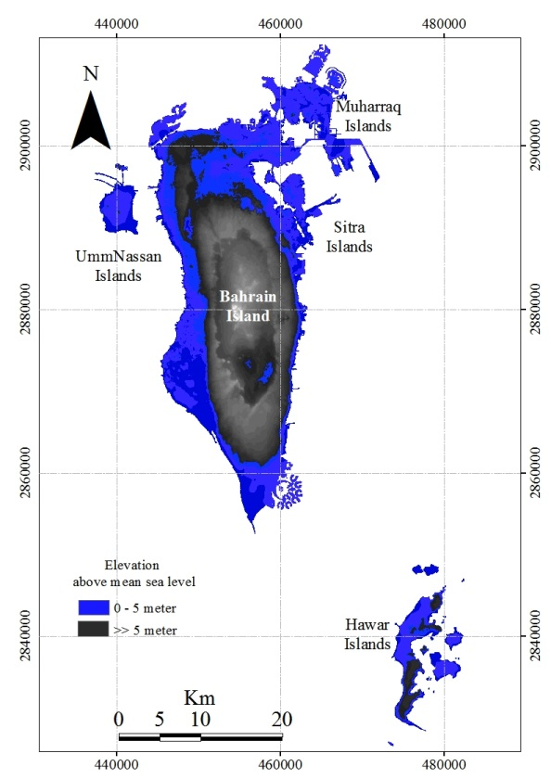
Figure 1. Kingdom of Bahrain (Source: Arabian Gulf University, Dr. Sabah Al-Jenaid)
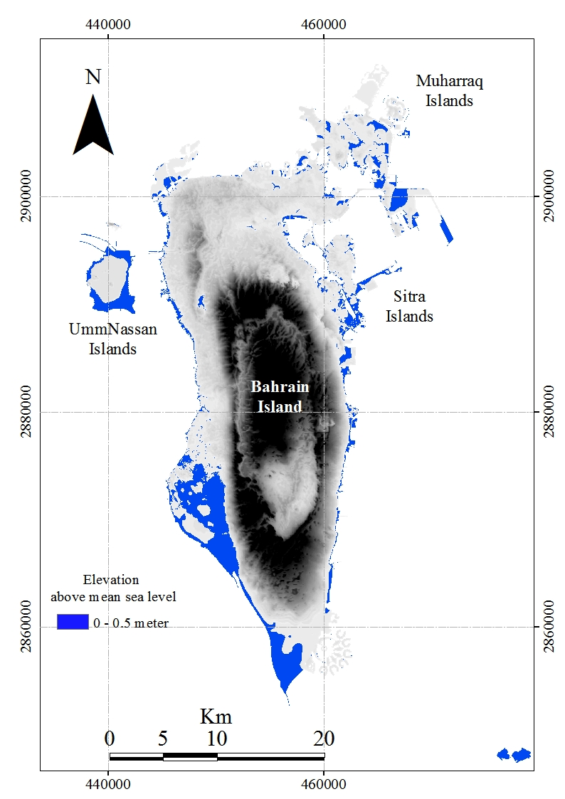
Figure 2: Land that could be inundated under a scenario 0.5 Sea Level Rise (Source: Arabian Gulf University, Dr. Sabah Al-Jenaid)
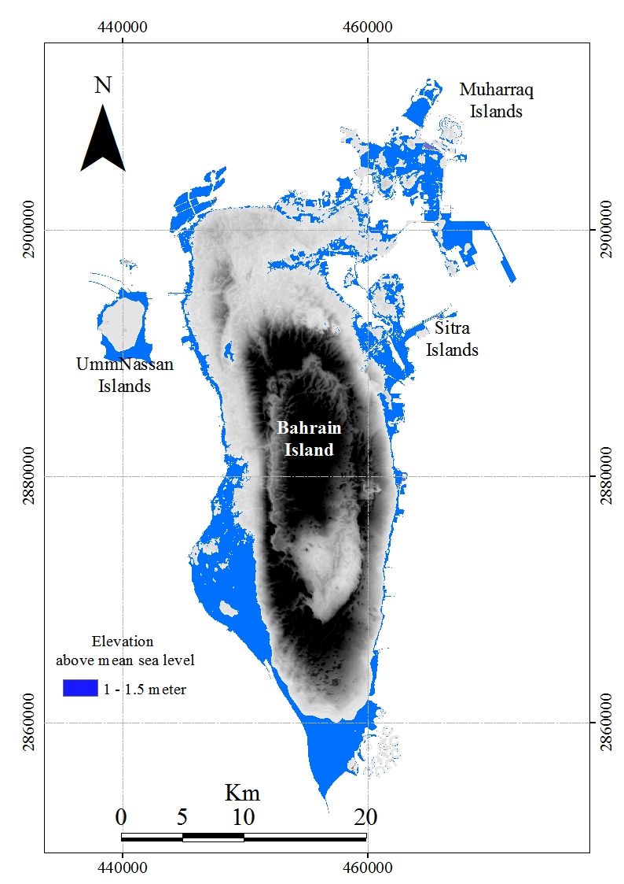
Figure 3: Land that could be inundated under a scenario 1-1.5 m Sea Level Rise (Source: Arabian Gulf University, Dr. Sabah Al-Jenaid)

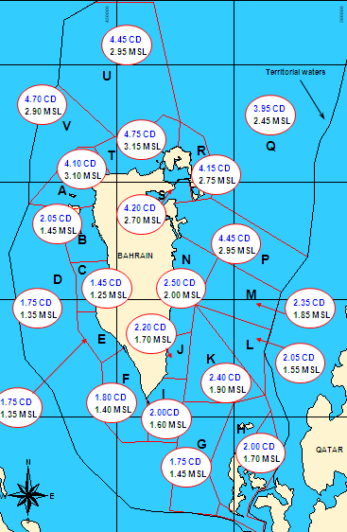
Source: Bahrain’s Ministry of Public Works recently released a new manual to be adhered for all land reclamation and dredging activity in the Kingdom (2010)

